## Preliminary Overview of In-Depth Rapid Test

## (MP 28.9 over the Garden State Parkway)

*25 April 2012*

## Introduction

The MP 28.9 Bridge carries Route 9 over the Garden State Parkway in southern Atlantic County, NJ (Figure 1). The bridge is comprised of four span simply-supported, multi-girder steel stringer spans that are constructed from welded plate girders. The bridge has two relatively short approach spans of 42 ft. and 53 ft. and two relatively long center spans of 147 ft. with all spans having a skew angle of 49 degrees. The six welded plate girders that support the longer spans were designed to act compositely with the deck and have numerous transitions to save materials. The diaphragms are of the X-type and there are diagonal wind bracing elements that run between the outside three girders along the bottom flange.

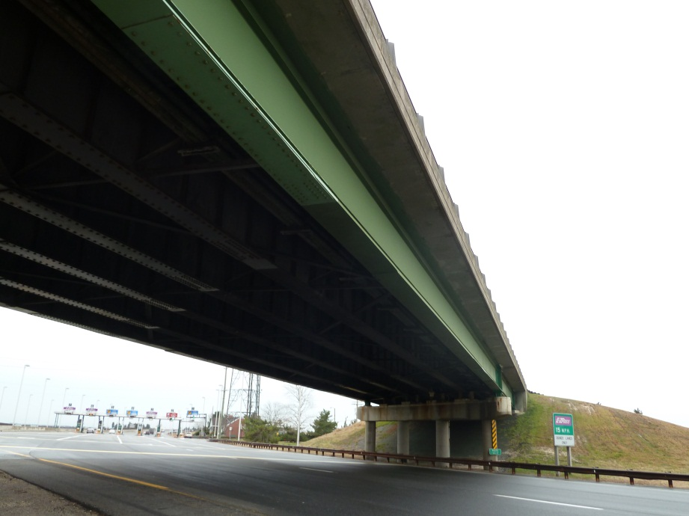

Figure : Span 2 of MP28.9 Bridge

The bridge is supported by common rocker bearings and the center spans are supported by reinforced concrete multi-column bents at either end. Unsymmetric, 12 in. deep sidewalks were constructed along either edge of the roadway and the railing is of a relatively light and open design. The deck has an asphalt overlay and stay-in-place-forms.

Due to capacity issues, in 1997, steel retrofit plates were bolted to the bottom flange of the girders within Spans 2 and 3 at the first bottom flange transitions. Since these plates were installed without shoring, they are only active in resisting live load effects (i.e. dead load and super-imposed dead load effects were locked into the original girders and the composite section, respectively).

Prior to a test, a conventional load rating was completed which showed that the bridge does not rate, specifically along the exterior girder and at the retrofit locations on all of the girders. An a-priori Finite Element (FE) Model was developed and used to conduct a model based load rating.

An in-depth, rapid test of span 2 of the MP28.9 Bridge was conducted on March 6, 2012 (figure 2). The primary objective for this test was to develop a means of validating the GSA system. The test included ambient traffic monitoring, static loading via trucks, and a forced vibration test. In developing the rapid testing method many additional benefits were explored and are discussed further in the following sections.

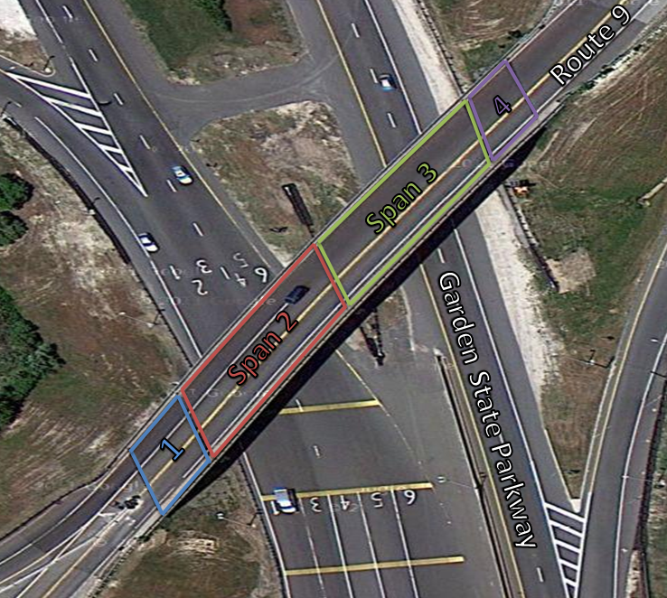

Figure : Aerial Photograph of MP28.9 Bridge

## Test Execution

The goal of the field investigation on the MP28.9 Bridge was to assess the condition of the structure and validate rating factors determined using a Finite Element (FE) Model. Additionally, custom rating factors will be determine for specific construction loading provided by New Jersey Turnpike.

Installation of gages began at 8:30 am and lasted until 10 am. Due to limited underside access, sensors could only be installed on the east half of span 2 as shown in the installation plan in Figure 3.

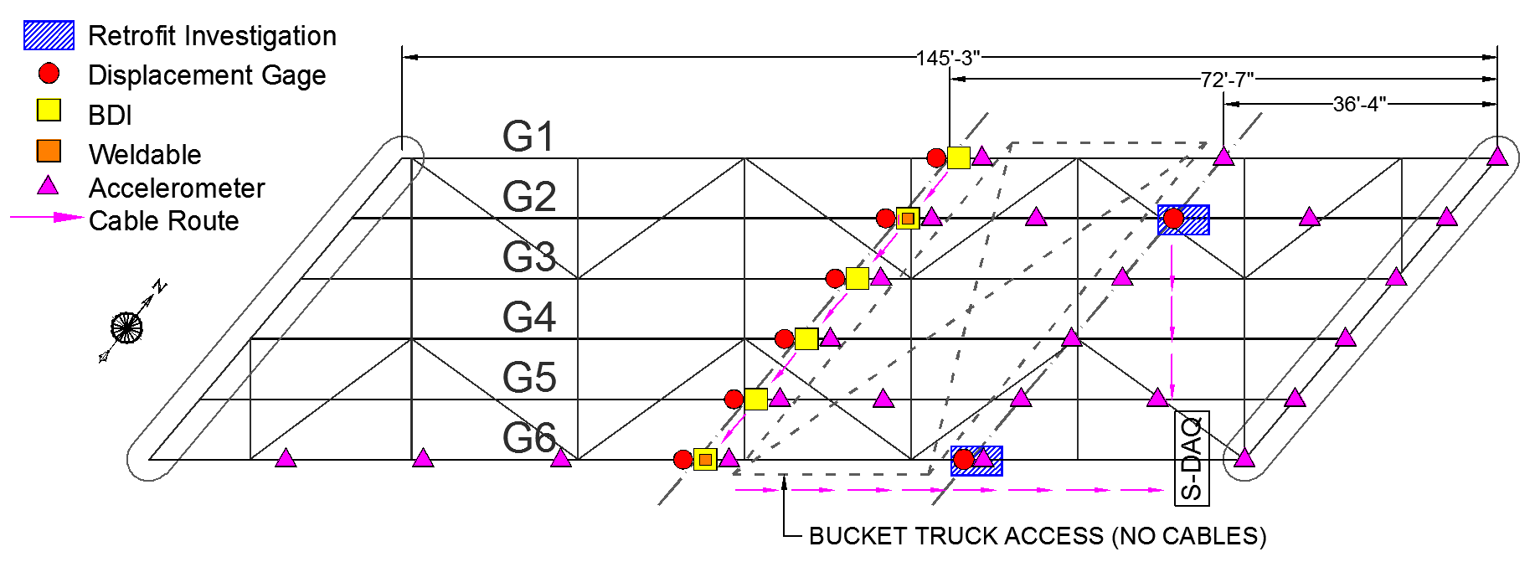

Figure 3: Instrumentation Plan

Displacement sensors and pairs of removable strain gages were installed on the bottom flange of each girder at midspan (Figure 4). Weldable strain gages were attached to girders 2 and 6 (found to control the conventional load rating analysis) at four locations on the cross-section at the retrofit plate and on the web at midspan (Figure 5). An optimized grid of fifteen accelerometers was attached to the underside of the girders using magnets. Additionally, twelve accelerometers were installed on the bearings to measure transmissibility. Finally an additional 3 accelerometers were installed topside on the sidewalk. The data acquisition equipment was located south of the pier between spans 2 & 3.

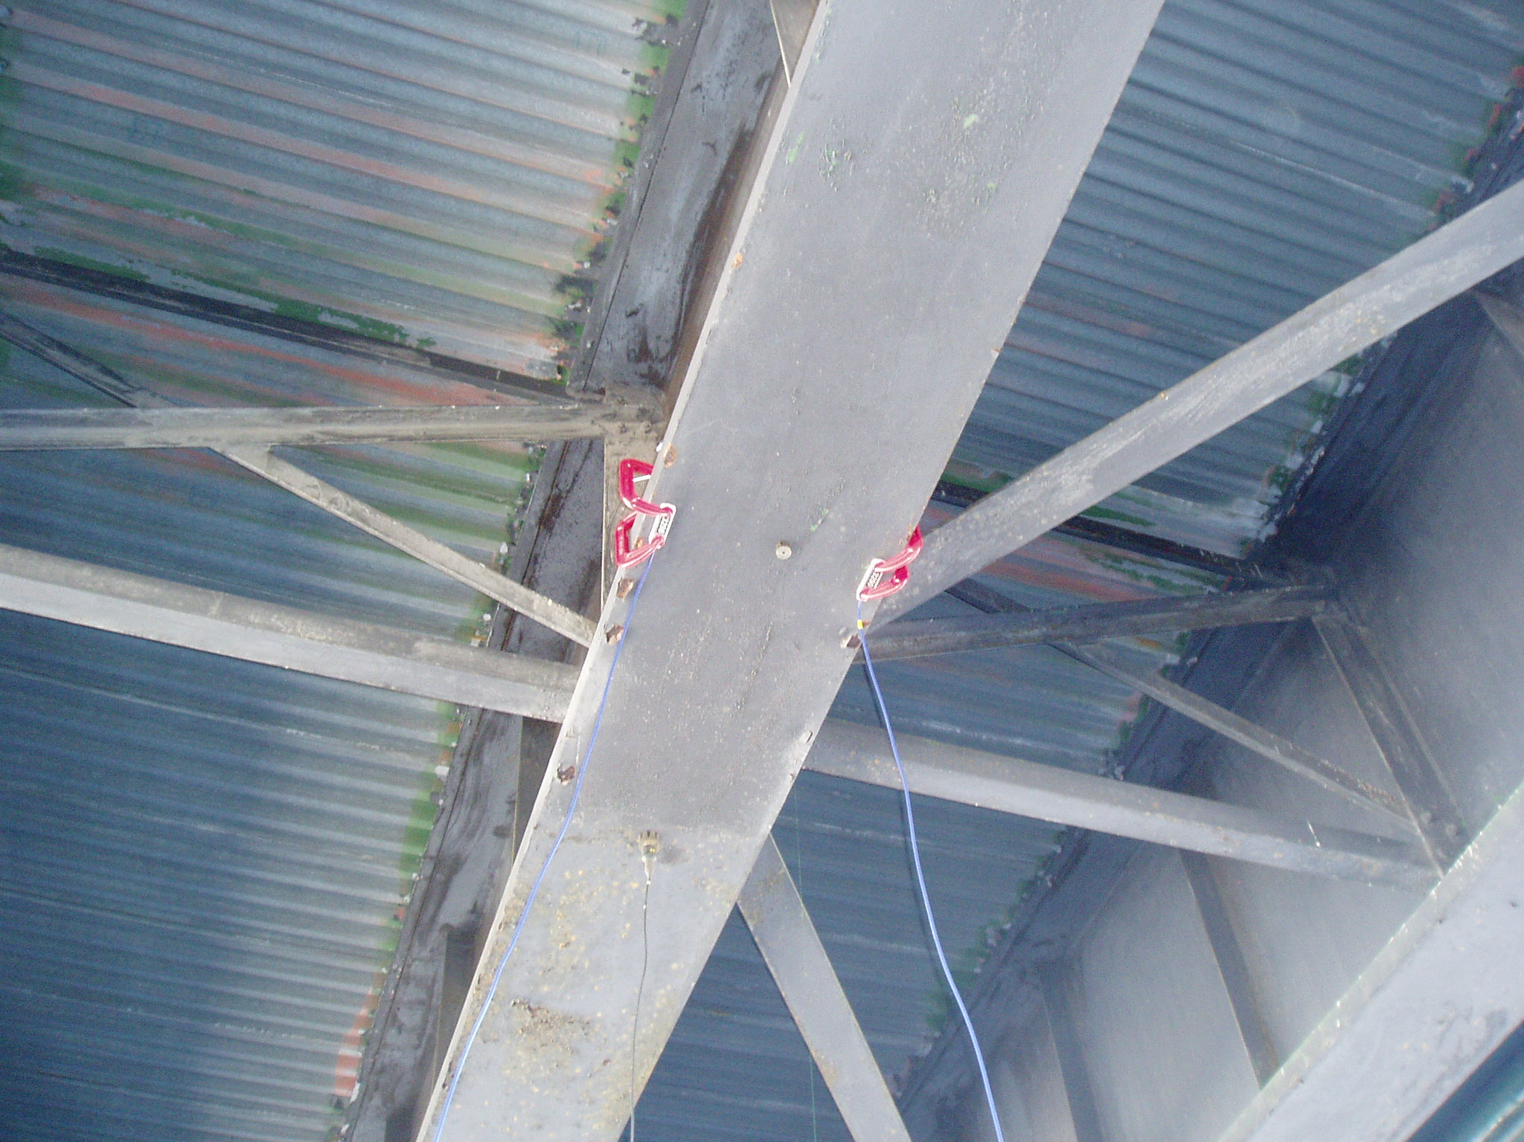 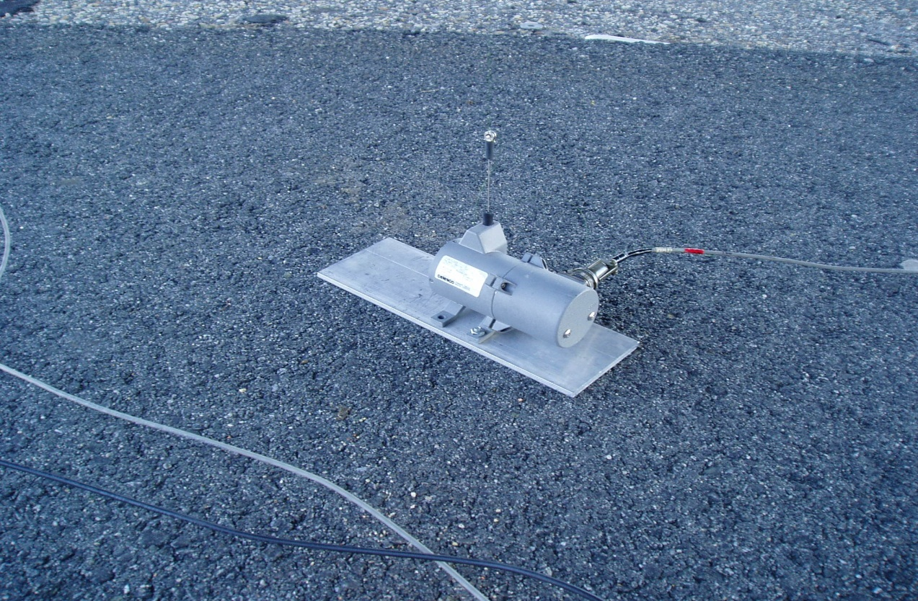

Figure 4: Midspan Strain and Displacement Sensors

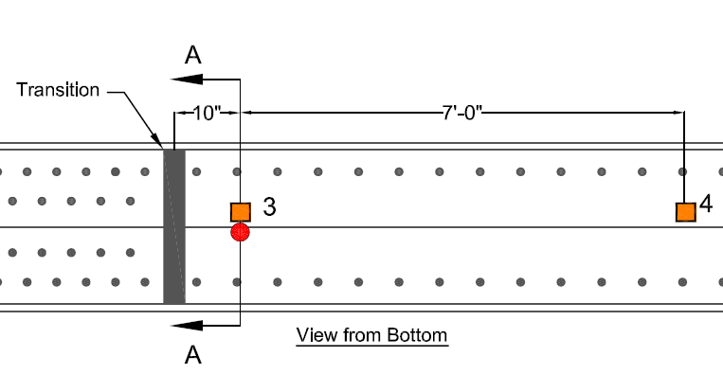 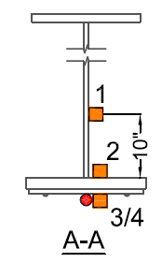

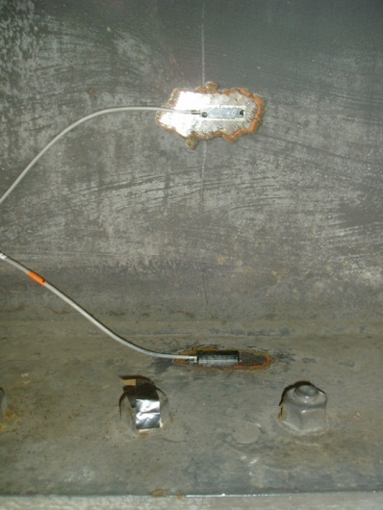

Figure 5: Weldable Strain Sensors at Retrofit Location

Three main test phases were carried out in order to obtain the information necessary to achieve the goals. Phase 1 was monitoring responses under ambient traffic excitation. Due to lack of traffic at the site location, two trucks were provided to ensure reasonable responses above noise thresholds were captured. This phase lasted for approximately an hour. Phase 2 consisted of crawl-speed and multi-configuration static testing of the span using two trucks loaded to approximately 65 kips (figure 6).

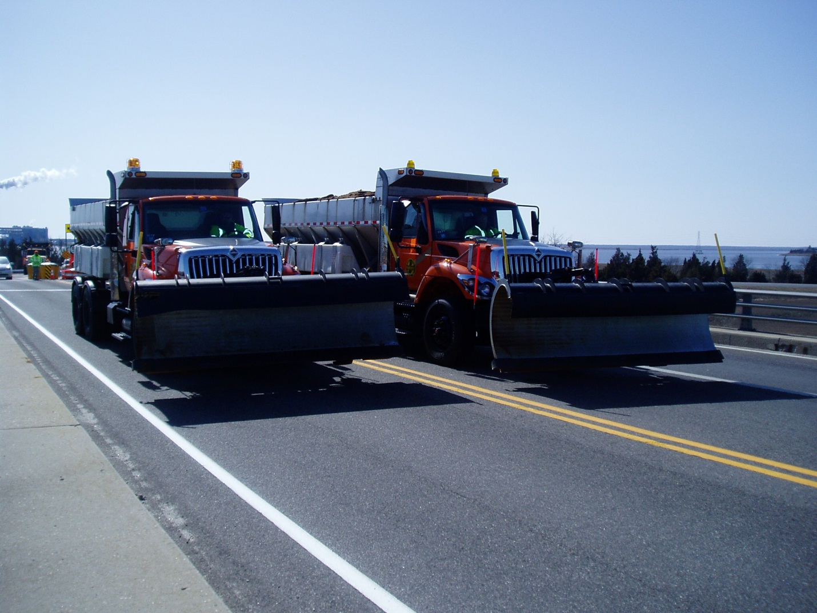

Figure 6: Static Truck Load Positioning at Midspan

Prior to the test, static truckloads of 72 kips were placed in 9 configurations within the model for two reasons, 1) to determine upper bounds of the expected responses from the static truck load test, and 2) to compare the real-time data in the field to determine if the behavior is as expected. Phase 3 consisted of a multi-reference impact test using forced excitation from a custom-built drop hammer capable of imparting up to 30 kips of dynamic force (figure7). This phase lasted approximately 2 hours completing the test. Finally all of the accelerometers, removable strain and displacement sensors were removed. A number of weldable strain sensors were left in place, which can be used for future testing. For this test, it was decided that two data acquisition units would be utilized; one for the strains and displacements (Static) and a separate unit for the accelerometers (dynamic). All equipment and cabling was removed and completed by 5:30.

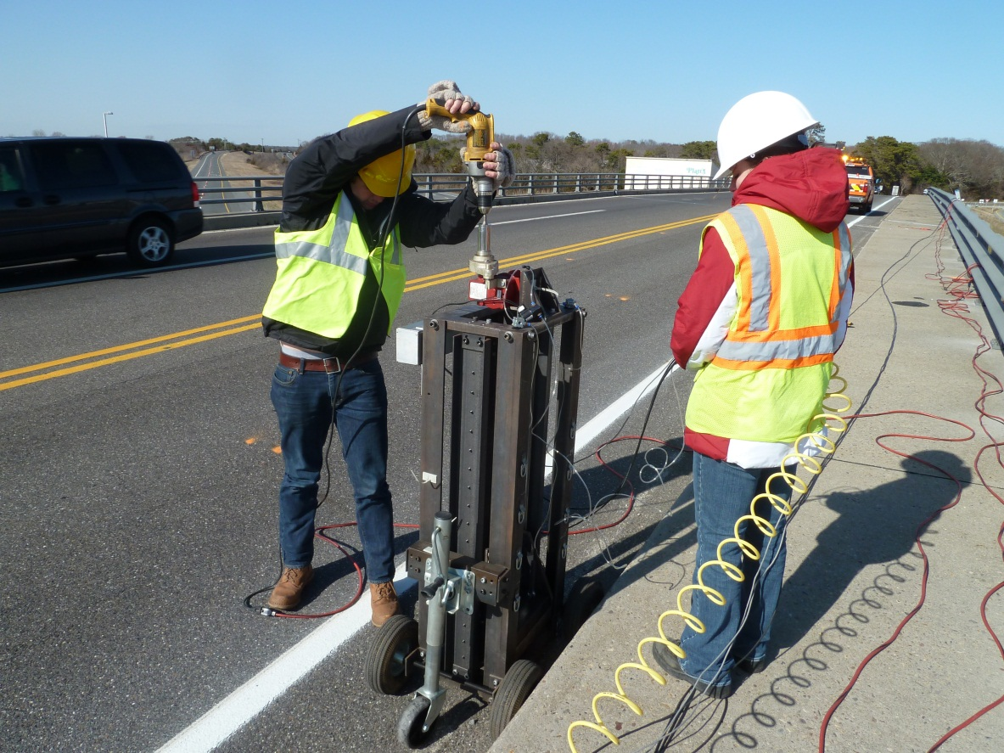

Figure 7: Custom-Built Drop Hammer

## Data Acquisition

National Instruments equipment was chosen for the data acquisition system for this test due to its functionality and ability to be customized. The data acquisition system allows measurements to be recorded from 9 displacement sensors, 12 BDI strain sensors and 14 weldable strain sensors simultaneously. Military connectors were attached to the outside of the data acquisition box, and wired directly to the data acquisition cards for easy hook-up. The sampling speed was set for 100 Hz for the static data and can easily be changed during a test.

## Real Time Data Visualization

Real time data visualization software was developed using Lab-View in order to evaluate the quality of the data on-site. The first panel, shown in figure 8, was developed for the monitoring phase under normal traffic demand and provides strain and displacement measurements as a function of time for the gages installed on the bottom flange of each girder at midspan. Since each girder had a strain sensor on either flange, the two individual strain measurements, along with the average, are plotted in order to make sure each sensor is reading properly and to obtain the strain measurement at the center of the girder. There are options to set the plots to auto-scale or manual to allow the ability to zoom in if needed. In the lower left there is an instrumentation plan, the sensor locations light up to indicate which sensor responses you are viewing at the moment. The sampling rate was set for 100 Hz during the test but can be changed if needed.

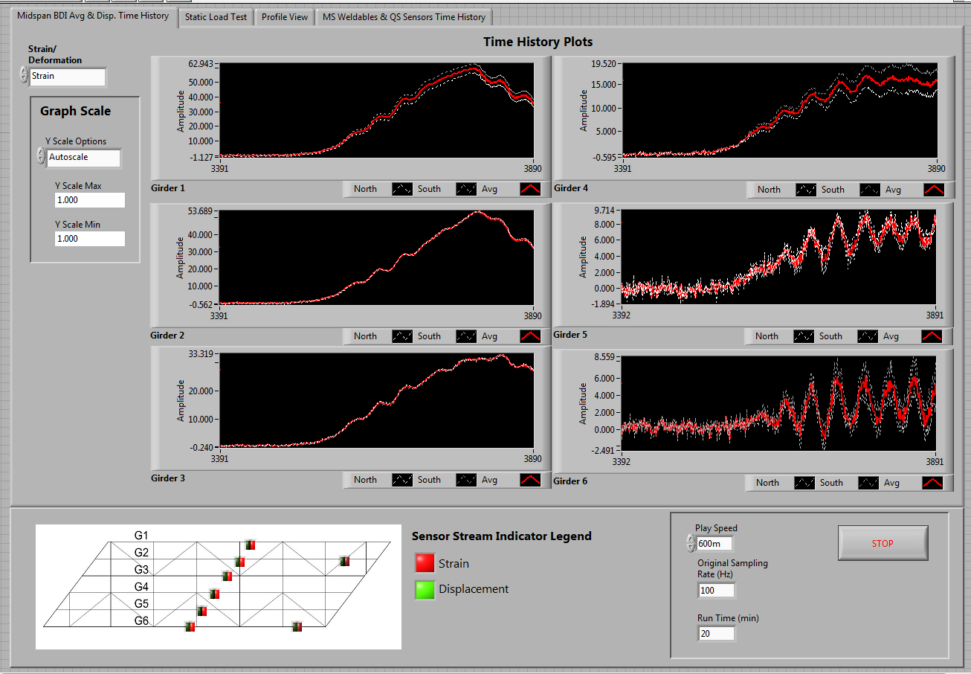

Figure 8: On-Site Data Visualization Software - Monitoring of Midspan Strains

The next two panels, shown in figures 9 and 10, were developed for the second phase during the static truck loading and crawl speed test. Using the measurements from the strain sensors installed on girders 2 and 6, on the flange and web, the neutral axis location is plotted for girders 2 and 6 at both the midspan location and the retrofit location (figure 9). The level of composite action can be evaluated by comparing these values with the calculated neutral axis locations for the conventional load rating analysis. Midspan displacement and strain profiles are plotted to be able to interpret data on site and compare with expected responses from the model. Finally there is an additional panel to show the raw data from all of the weldable strain sensors to make sure the measurements look reasonable and to ensure that all sensors are working properly.

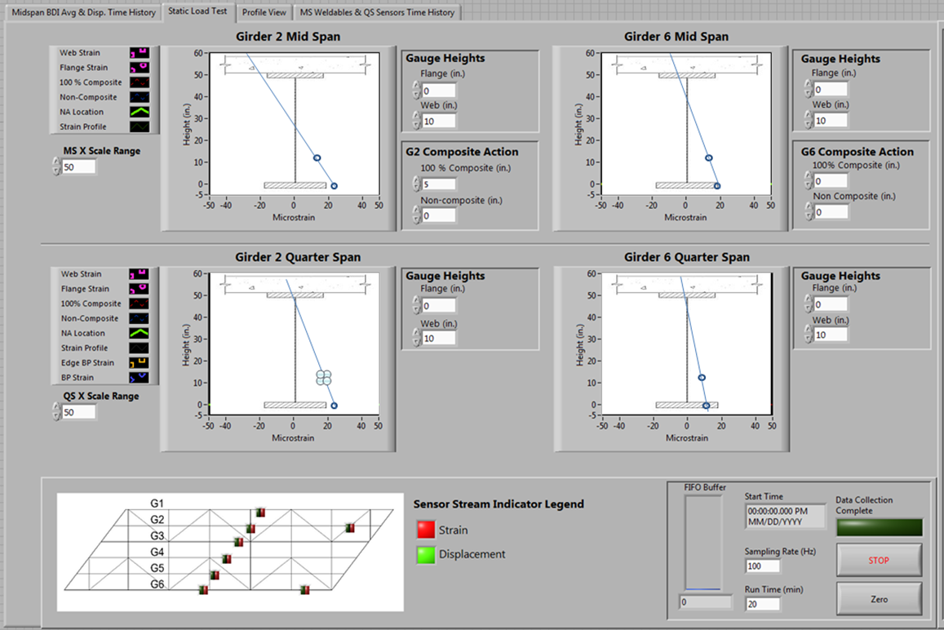

Figure 9: On-Site Data Visualization - Neutral Axis Plots

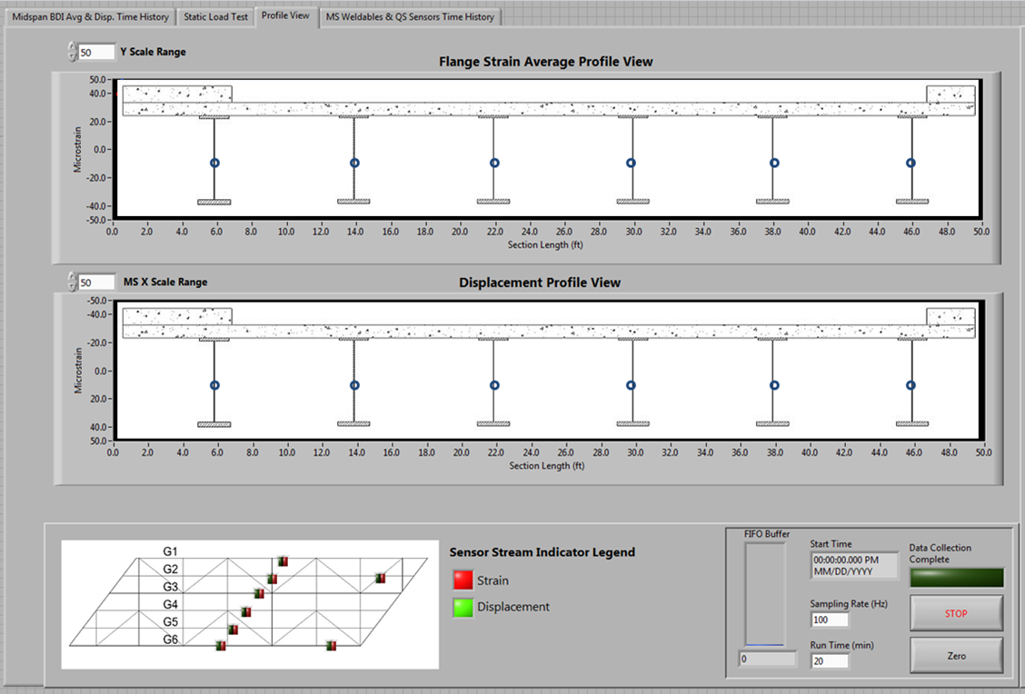

Figure 10: On-Site Data Visualization Software - Strain and Displacement Profiles

## Data Processing and Visualization

An automated data processing program has been developed in order to quickly process each data set and extract pertinent information pertaining to the performance of the bridge. The raw time histories of related sensors are plotted in order to distinguish any abnormities or discrepancies in the responses. The data is then filtered to reduce any affects from noise; if there is a drift present in the response for any sensor the trend is removed; and any offsets are subtracted. The two removable strain sensors, which are attached to either flange of each girder, are averaged to obtain the strain value at the center of the bottom flange. The “cleaned” data is also plotted to compare with the raw time histories (figure 11).

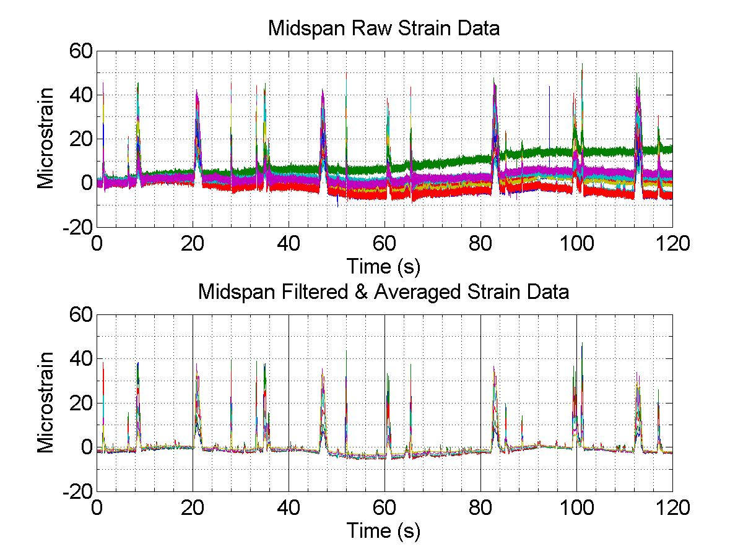

Figure 11: Example of Raw and Processed Midspan Strain Data

## Data Interpretation

Once the data has been processed, many relationships can be examined to inform about the actual behavior of the bridge. Considering that the idea of rapidly testing a bridge for information such as distribution factors, strain/displacement profiles, and, in this case, determine an experimental load rating, is still in the process of being developed, the static load test along with the crawl speed tests were crucial to verify all findings during the monitoring under normal traffic conditions. Data interpretation for both the static truck load testing and monitoring phases is discussed below.

Phase 1 – Monitoring:

After the raw data is processed, an algorithm within the automated program was designed to recognize truck events and distinguish which lane the vehicle was positioned in. The “cleaned” data is then plotted with markers designating these truck events for visual verification (figure 12).

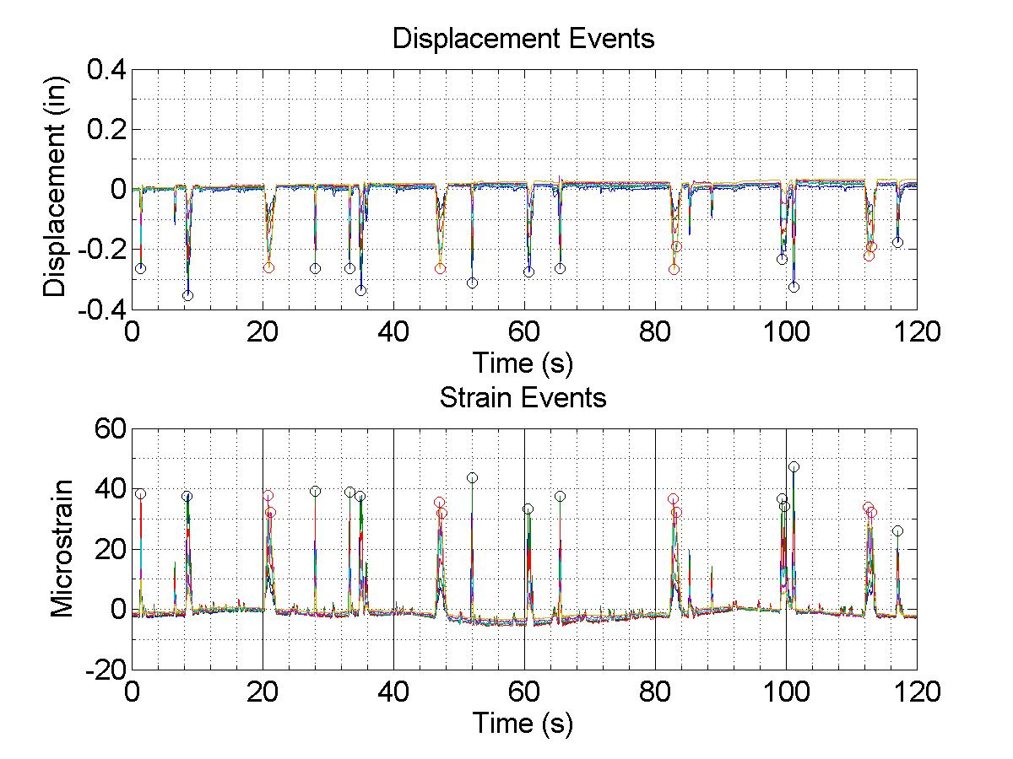

Figure 12: Distinguish Peak Truck Events

From these truck events distribution factors can be calculated. Box plots are developed showing the distribution factors based on strain and displacement as well as lane position (figure 13). Based off of the hand calculated conventional load rating the exterior girders had a distribution factor of 0.67 and the interior girder of 0.56. Experimentally the highest distribution factor is 0.32.

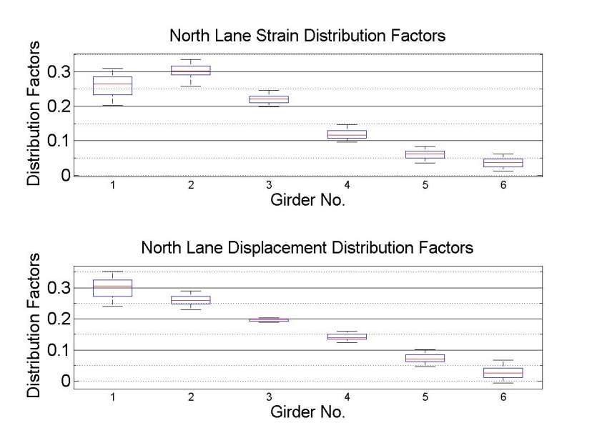

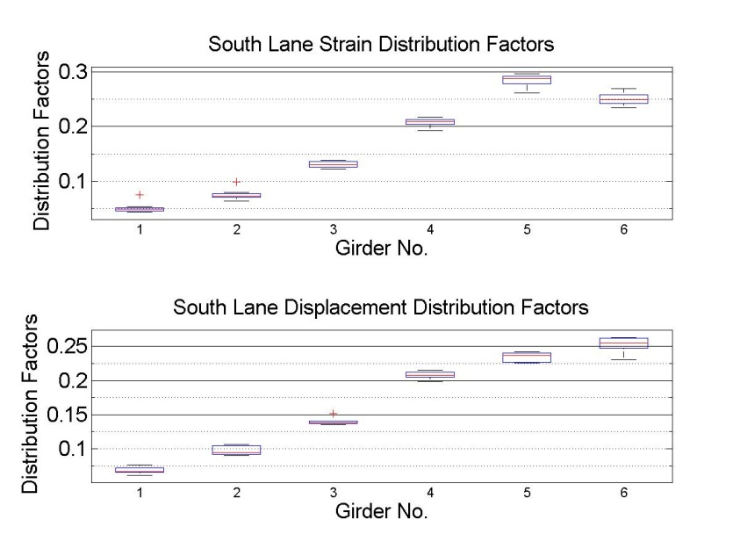

Figure 13: Distribution Factors for Trucks in North Lane and Trucks in South Lane

At four locations, several strain gages were installed along the height of the girder which provides a full strain profile at that cross-section. These setups were installed in order to provide us with more information about the level of composite action.

The composite and non-composite neutral axis locations were calculated previously for the hand calculated conventional load rating. For full composite action the neutral axis must be located above 46 in from the bottom flange at midspan and above 52 in from the bottom flange at ¼ span. The results indicate that the bridge is in fact fully composite (figure 14).

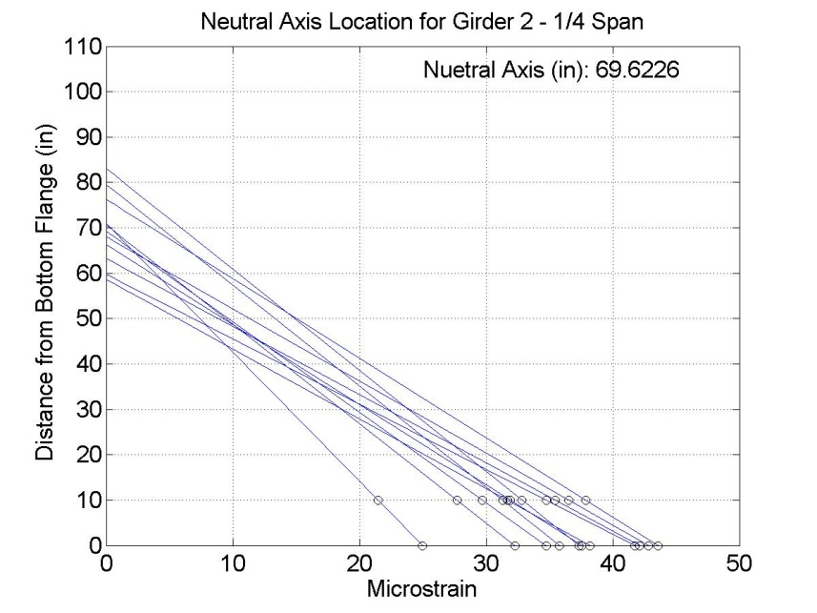

Figure 14: 1/4 Span Neutral Axis Location for Girder 2

Sensors were also installed near the flange transition at the retrofit cover plates located on girders 2 and 6. The strains measured on the cover plates are approximately equal to the strains measured on the parent girder indicating that the cover plates are actively resisting live load. An additional gage located on the cover plate 7 ft. from the transition showed that the plate is indeed fully developed over that length (figure 15).

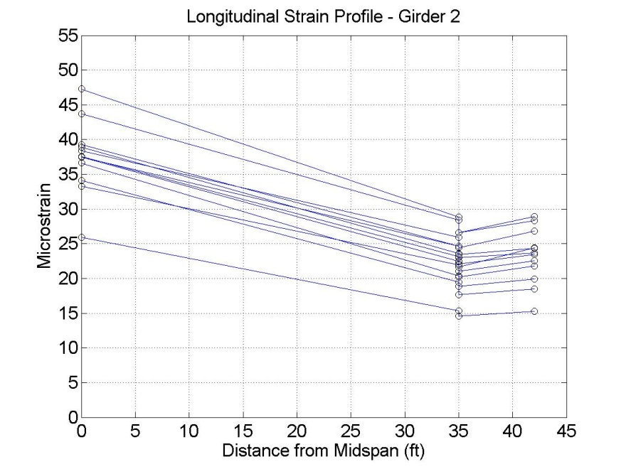

Figure 15: Longitudinal Strain Profile for Girder 2

Using the oscillation in the truck responses experimental impact factors could be determined. The maximum impact factor found was 1.15 and the minimum impact factor was approximately 1.02.

Phase 2 – Static Truck Load Test:

Immediately after completion of the test, the truck loads used for the static truck load phase were input into the model. Displacement and strain responses were then extracted from the model at the sensor locations from the test. Comparisons between the model results and the true measurements were conducted and from these comparisons many conclusions can be stated. All of the measured displacements did not exceed the predicted values from the model. Typically there was a 5-15% decrease in displacement as compared to the model predictions. The displacements from the model along with the measured displacements for the load case with a single truck in the South Lane at midspan are plotted in figure 16, with the far most left points being girder 6 and the far most right girder 1. All of the measured strains were 20-40% lower than the predicted values from the model as well. The strains from the model and the measured strain from the same load case as previously mention are plotted in figure 17. Such discrepancies between a FE Model and real test measurements are common.

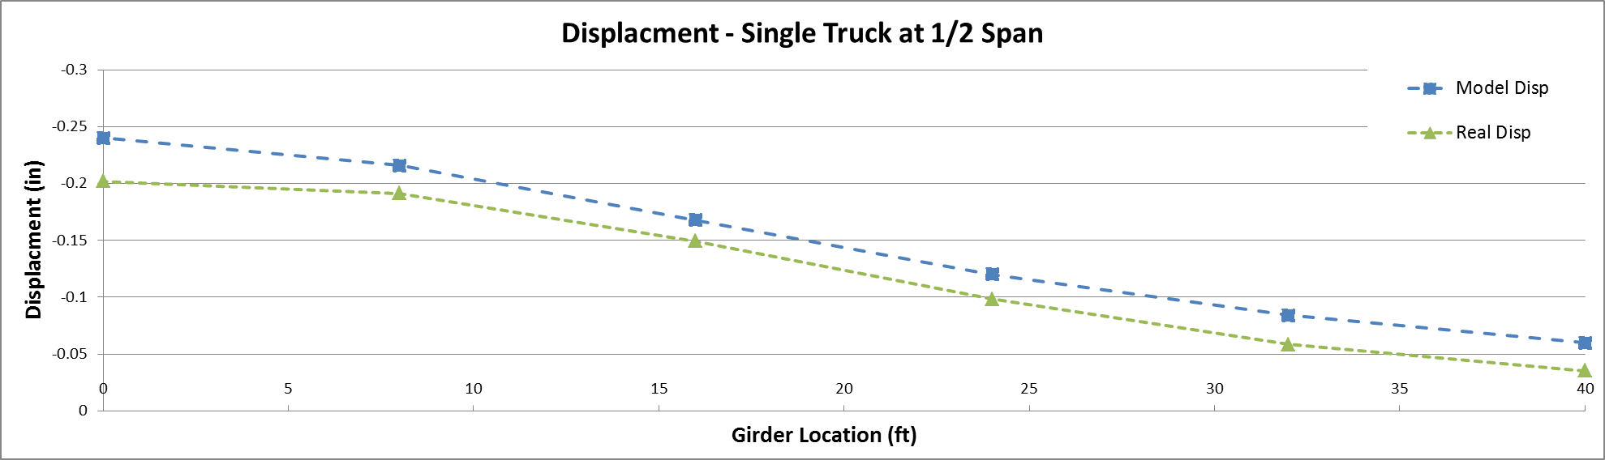

Figure 16: Comparison between Model and Measured Displacements

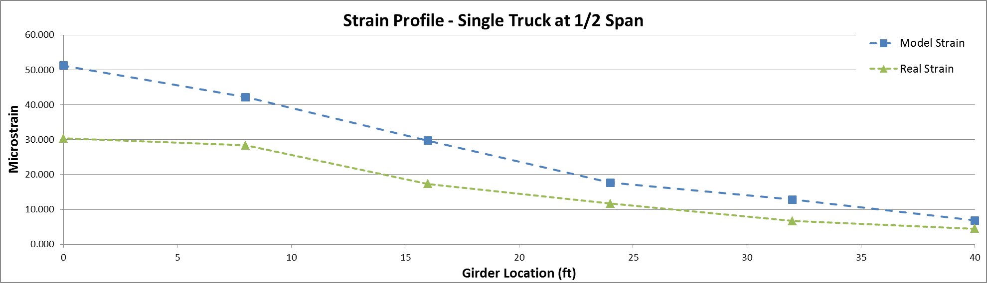

Figure 17: Comparison between Model and Measured Strains

## Custom Rating Factors

Overload construction vehicle dimensions and weights were provided to be used in the FE Model and to develop custom rating factors. Each vehicle was input into the model with a multiple presence factor of 1.2 in order to compare to the conventional load rating calculations completed per code. It should be noted that the trucks were only allowed to be in a single lane at a time, not multiple lanes. The responses from the model were then used to calculate distribution factors and rating factors. For all five load cases the distribution factors were consistent with the highest distribution factor being 0.20. The rating factors were calculated using an impact factor of 1.33 per code, 1.15 which was the maximum impact factor measured experimentally, and 1.00 which would acceptable to use if the vehicle were crawled across the bridge at about 5 mph.

All of the controlling rating factors occurred at the retrofit locations for each load case. The operating rating factors for each load case are presented in tables 1 to 5 below for each vehicle provided. A conventional load rating was also completed for each vehicle configuration for an interior girder and for the controlling exterior girder (G6). The model based rating factors were then compared to the conventional analysis to determine scaling factors for future load rating of additional vehicles. It should be noted that scaling factors are not provided for girder 1, since a conventional load rating was not completed for this girder, and for girder 6 since the rating factors determined through the conventional load rating was zero for all five load cases. It should also be noted that every girder had a model based rating above 1.35 with an impact factor of 1.00, above 1.18 with an impact factor of 1.15, and above 1.02 when using an impact factor of 1.33. The lowest scaling factor determined was 1.20 and the highest scaling factor is 3.52. The scaling factors have a wide range depending on the truck configuration. The individual ranges for a specific truck are narrower with the range of the C-4-108 scaling factors being the smallest of 0.49 and the OT-3-78 scaling factors having the largest range of 0.91.

Table 1: C-4-108 Rating Factors and Scaling Factors

|  |  |  |  |  |  |
| --- | --- | --- | --- | --- | --- |
| **C-4-108** | **Conventional** | **Model** | | | **Scaling** |
| ***IM = 1.33*** | ***IM = 1.33*** | ***IM = 1.15*** | ***IM = 1.00*** | ***IM = 1.00*** |
| **Girder 1** | NA | 1.02 | 1.18 | 1.35 | ***NA*** |
| **Girder 2** | 0.90 | 1.16 | 1.34 | 1.54 | ***1.20*** |
| **Girder 3** | 0.90 | 1.48 | 1.71 | 1.97 | ***1.45*** |
| **Girder 4** | 0.90 | 1.90 | 2.19 | 2.52 | ***1.69*** |
| **Girder 5** | 0.90 | 1.46 | 1.69 | 1.94 | ***1.42*** |
| **Girder 6** | -0.21 | 1.12 | 1.30 | 1.49 | ***NA*** |

Table 2: C-5-135 Rating Factors and Scaling Factors

|  |  |  |  |  |  |
| --- | --- | --- | --- | --- | --- |
| **C-5-135** | **Conventional** | **Model** | | | **Scaling** |
| ***IM = 1.33*** | ***IM = 1.33*** | ***IM = 1.15*** | ***IM = 1.00*** | ***IM = 1.00*** |
| **Girder 1** | NA | 1.67 | 1.93 | 2.22 | ***NA*** |
| **Girder 2** | 0.72 | 1.95 | 2.26 | 2.60 | ***2.53*** |
| **Girder 3** | 0.72 | 2.46 | 2.84 | 3.27 | ***3.09*** |
| **Girder 4** | 0.72 | 2.48 | 2.86 | 3.29 | ***3.12*** |
| **Girder 5** | 0.72 | 2.09 | 2.42 | 2.79 | ***2.63*** |
| **Girder 6** | -0.17 | 1.71 | 1.98 | 2.27 | ***NA*** |

Table 3: OT-3-70 Rating Factors and Scaling Factors

|  |  |  |  |  |  |
| --- | --- | --- | --- | --- | --- |
| **OT-3-70** | **Conventional** | **Model** | | | **Scaling** |
| ***IM = 1.33*** | ***IM = 1.33*** | ***IM = 1.15*** | ***IM = 1.00*** | ***IM = 1.00*** |
| **Girder 1** | NA | 3.27 | 3.79 | 4.35 | ***NA*** |
| **Girder 2** | 1.33 | 3.62 | 4.19 | 4.82 | ***2.61*** |
| **Girder 3** | 1.33 | 4.60 | 5.32 | 6.12 | ***3.17*** |
| **Girder 4** | 1.33 | 5.32 | 6.15 | 7.07 | ***3.52*** |
| **Girder 5** | 1.33 | 4.07 | 4.71 | 5.41 | ***2.81*** |
| **Girder 6** | -0.31 | 3.52 | 4.07 | 4.68 | ***NA*** |

Table 4: OT-4-78 Rating Factors and Scaling Factors

|  |  |  |  |  |  |
| --- | --- | --- | --- | --- | --- |
| **OT-4-78** | **Conventional** | **Model** | | | **Scaling** |
| ***IM = 1.33*** | ***IM = 1.33*** | ***IM = 1.15*** | ***IM = 1.00*** | ***IM = 1.00*** |
| **Girder 1** | NA | 3.02 | 3.49 | 4.02 | ***NA*** |
| **Girder 2** | 1.21 | 3.32 | 3.84 | 4.42 | ***2.60*** |
| **Girder 3** | 1.21 | 4.24 | 4.90 | 5.63 | ***3.18*** |
| **Girder 4** | 1.21 | 4.60 | 5.33 | 6.12 | ***3.35*** |
| **Girder 5** | 1.21 | 3.54 | 4.10 | 4.71 | ***2.71*** |
| **Girder 6** | -0.28 | 3.01 | 3.48 | 4.00 | ***NA*** |

Table 5: OT-5-100 Rating Factors and Scaling Factors

|  |  |  |  |  |  |
| --- | --- | --- | --- | --- | --- |
| **OT-5-100** | **Conventional** | **Model** | | | **Scaling** |
| ***IM = 1.33*** | ***IM = 1.33*** | ***IM = 1.15*** | ***IM = 1.00*** | ***IM = 1.00*** |
| **Girder 1** | NA | 2.36 | 2.73 | 3.14 | ***NA*** |
| **Girder 2** | 0.95 | 2.71 | 3.14 | 3.61 | ***2.68*** |
| **Girder 3** | 0.95 | 3.44 | 3.98 | 4.58 | ***3.31*** |
| **Girder 4** | 0.95 | 3.64 | 4.21 | 4.84 | ***3.43*** |
| **Girder 5** | 0.95 | 2.96 | 3.43 | 3.94 | ***2.82*** |
| **Girder 6** | -0.22 | 2.49 | 2.88 | 3.31 | ***NA*** |

## Future Work

Based on the findings the model appears to be conservatively representative of the behavior of the structure and all model based rating factors were determined to be above 1.00 for operating level. An additional load rating will be developed after the model is further improved and error screened. The preliminary model did not explicitly include the wearing surface, barrier, and longitudinal stiffeners on the exterior girders. These will be added and the model will be parameterized to allow for optimization. The model will be optimized using parameters including material properties, partial boundary restraints, and inclusion of non-structural components like the barriers and wearing surface, along with modal parameters. Rating factors will be calculated using appropriate modeling scenarios (i.e. dead load stresses from non-composite section properties). The resulting model can be used for additional load cases and permit load ratings.